Capstone Project
Full VAPT Cycle

Name: Vijayashree B
Domain: Cybersecurity (VAPT)
Date of Submission: 20.03.26

Capstone Project: Full VAPT Cycle

- Objective:
The objective of this capstone project is to perform a full Vulnerability Assessment and Penetration Testing (VAPT) cycle on a controlled lab environment (Metasploitable & DVWA). The assessment follows the PTES (Penetration Testing Execution Standard) methodology, including simulation, detection, exploitation, remediation, and reporting.

- Tools Used:
• Kali Linux
• sqlmap
• Metasploit Framework
• Nuclei
• Burp Suite

- Target Details:
- Target Machine: Metasploitable
- Target IP: 192.168.56.101
- Web App: DVWA
- Attacker Machine: Kali linux

- PTES Phase Applied
- Reconnaissance
- Scanning & Enumeration
- Exploitation
- Post-Exploitation
- Reporting

- Simulation (SQL Injection using sqlmap)
A SQL Injection attack was simulated on DVWA.
Command used: (sqlmap -u "http://192.168.56.101/dvwa/vulnerabilities/sqli/?id=1&Submit=Submit" --cookie="security=low; PHPSESSID=265e12a088f6e49c371d3469077341c2" –dbs)

To get PHPSESSID using burpsuite:

Steps:
- Open Burp Suite → Proxy → Intercept ON
- Set browser proxy: 127.0.0.1:8080
- Login to DVWA (admin / password)
- Go to SQL Injection page and click Submit
- In Burp, capture request
- In cookies: PHPSESSID=265e12a088f6e49c371d3469077341c2; security=low.
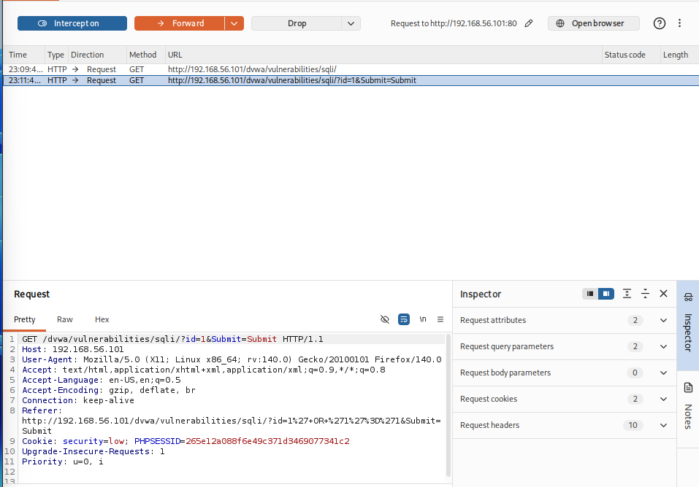
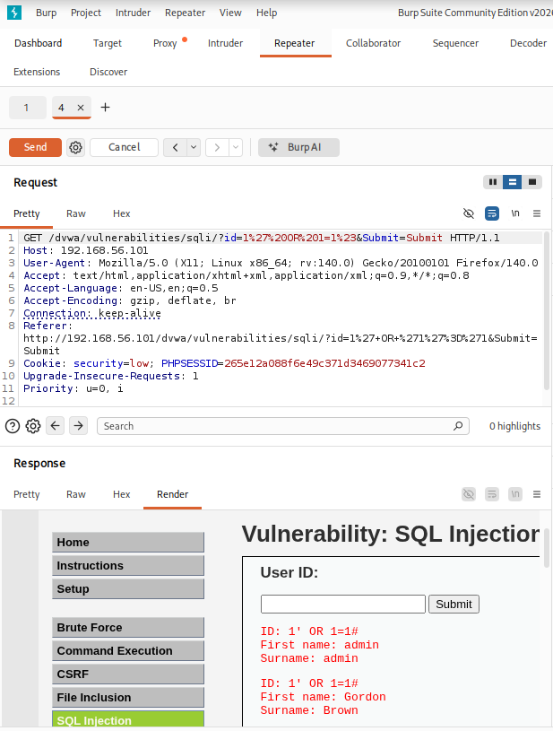

Sqlmap Simulations:

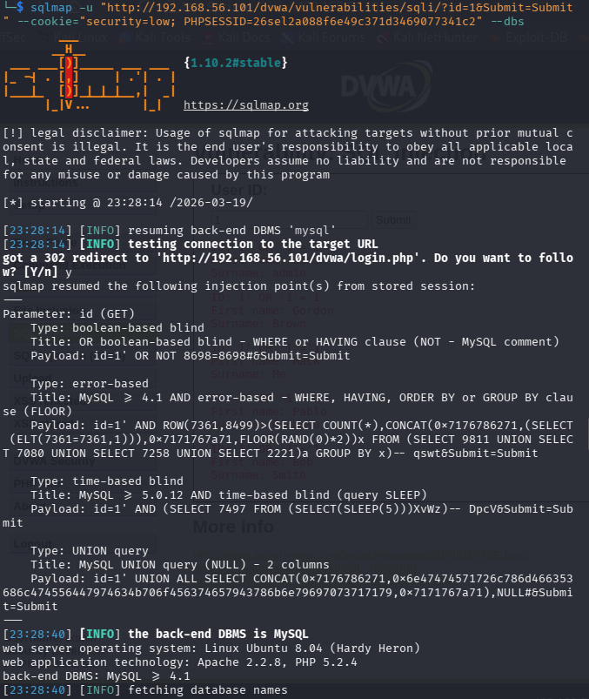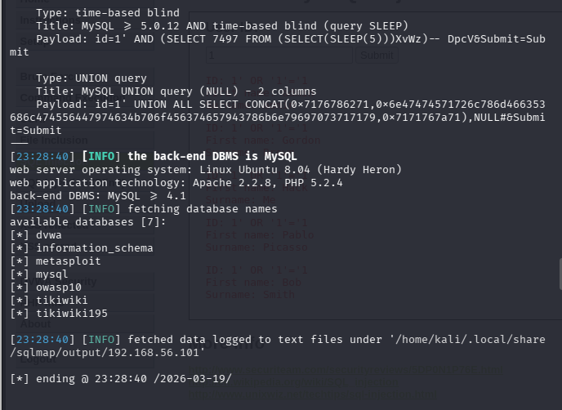

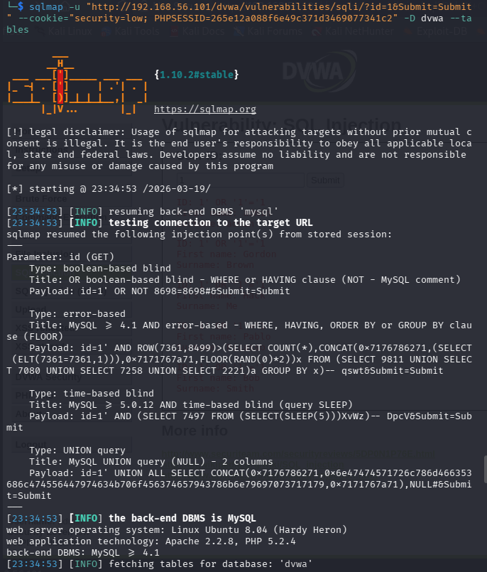
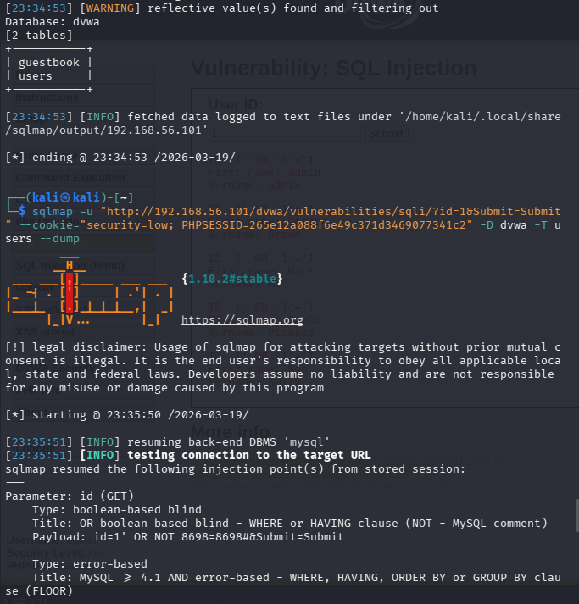

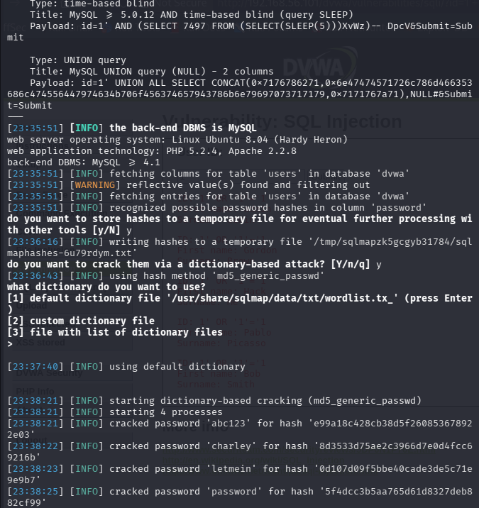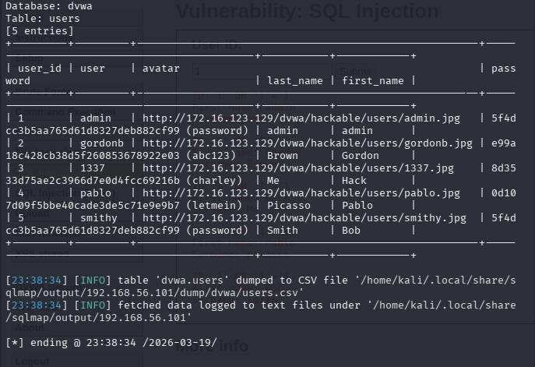
Results:
- Vulnerability confirmed
- Database identified: dvwa
- Extracted tables: users
- Dumped credentials (usernames & passwords)
This confirms that the application is vulnerable to SQL Injection due to improper input validation

- Detection (Nuclei Findings Log):

Timestamp | Target IP | Vulnerability | PTES Phase
2026-03-19 23:38:34 | 192.168.56.101 | SQL Injection | Exploitation
2026-03-19 23:40:00 | 192.168.56.101 | Missing Security Headers | Scanning
2026-03-19 23:42:00 | 192.168.56.101 | Directory Listing Enabled | Scanning
2026-03-19 23:45:00 | 192.168.56.101 | Outdated Apache Version | Enumeration

The above findings were identified using Nuclei automated scanning. The following screenshot shows the actual scan output highlighting detected vulnerabilities and their severity levels.
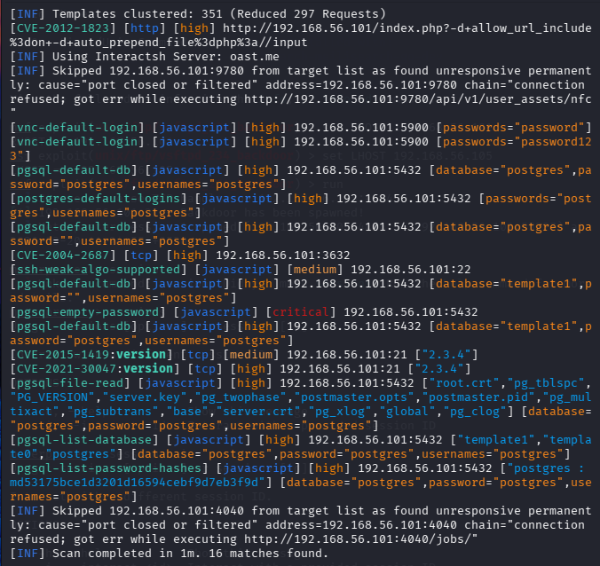
Nuclei Scan Output Showing Detected Vulnerabilities with Severity Levels

- Analysis of Finding:

The Nuclei scan revealed multiple vulnerabilities across the target system, including missing security headers, directory listing enabled, outdated Apache server version, and the presence of default credentials. These vulnerabilities indicate poor security configurations and lack of proper system hardening.
Missing security headers such as Content-Security-Policy and X-Content-Type-Options expose the application to attacks like Cross-Site Scripting (XSS) and MIME-type sniffing. Directory listing enabled on the server allows attackers to view sensitive files and directories, which can lead to information disclosure.
The use of outdated software components increases the risk of exploitation, as these versions are known to contain publicly available vulnerabilities. Additionally, the presence of default or weak credentials significantly lowers the barrier for attackers to gain unauthorized access.
The SQL Injection vulnerability identified in the DVWA application further highlights improper input validation and insecure coding practices. This type of vulnerability allows attackers to manipulate database queries and extract sensitive information.
Overall, the findings demonstrate that the system is vulnerable at multiple levels, including application, server, and configuration layers. If exploited, these vulnerabilities could lead to data breaches, unauthorized access, and complete system compromise.

- Exploitation Summary:

The identified vulnerabilities were successfully exploited to demonstrate their real-world impact. A SQL Injection attack was performed on the DVWA application using sqlmap, which allowed extraction of database information including user credentials.
In addition, Metasploit Framework was used to exploit vulnerable services on the target system. This demonstrated the possibility of remote code execution and unauthorized access to the system.
These successful exploitations confirm that the identified vulnerabilities are critical and can lead to serious security breaches if not addressed.
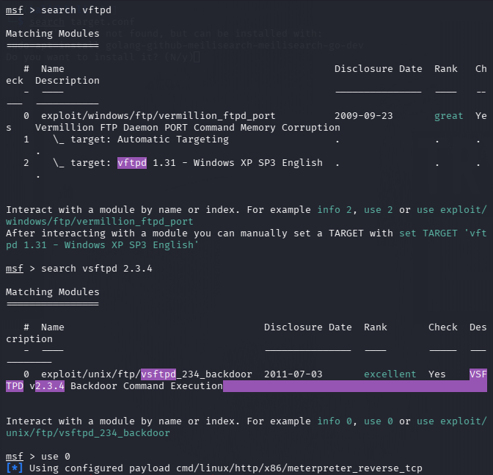
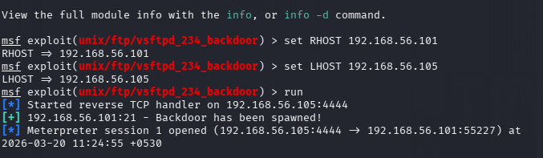
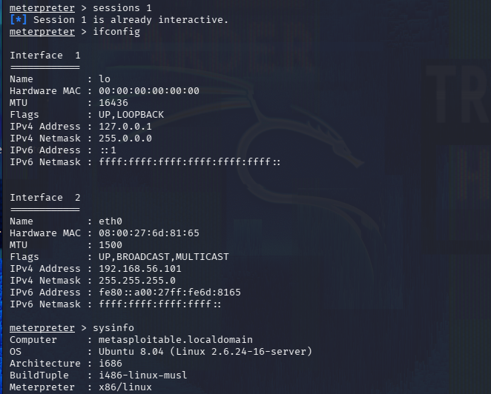

- Risk Impact:

- The identified vulnerabilities can lead to:
- Unauthorized access to sensitive data
- Database compromise
- Remote code execution
- Full system takeover
- Increased attack surface

- Remediation:

To secure the system, the following measures are recommended:
- Implement input validation and prepared statements
- Remove default credentials
- Update and patch outdated services
- Disable unnecessary services
- Add security headers (CSP, HSTS)
- Restrict access to sensitive components

- Conclusion:

The full VAPT cycle successfully identified and validated multiple vulnerabilities in the target system, including web application flaws and misconfigured services. Exploitation of SQL Injection confirmed the presence of critical security weaknesses that could lead to unauthorized data access and system compromise.
The recommended remediation measures, such as input validation, patching outdated software, and removing default credentials, are essential to improve the overall security posture of the system. Implementing these controls will significantly reduce the risk of future attacks.
This assessment highlights the importance of regular security testing, continuous monitoring, and proper system hardening to protect against evolving cyber threats.

